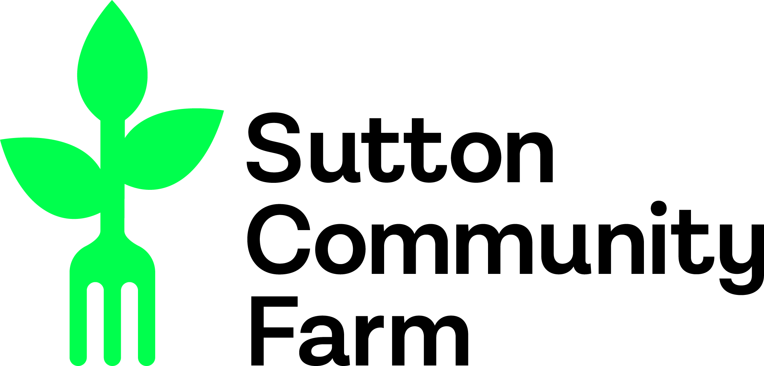
Please answer the following questions with a short paragraph each, using examples from your experience to support your answers. Send your answers along with your CV to the growing team at joris@suttoncommunityfarm.org.uk.

- Where did you hear about this job?

- What prompted you to apply for this job, and why would you like to work at Sutton Community Farm?

- Where do you see this job taking you after the 20 month apprenticeship? What is your long term plan?

- Tell us about your journey to wanting to work in sustainable food, including your experiences of food growing so far?

- What are the three most important qualities or skills you would bring to the farm?

- What has been your greatest achievement, i.e. what are you most proud of, and why?

- Imagine you have your own farm in the future. What would it look like?

- What experience do you have managing/supervising people/volunteers?

