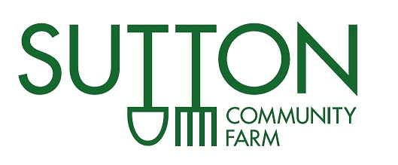

Job Title: VegBox Delivery Driver
Start Date: 26th October 2018 or as soon as possible thereafter
Hours: 1 day per week on Fridays
Salary: £10.20/hr
Website: www.suttoncommunityfarm.org.uk

JOB PROFILE
Sutton Community Farm is a community-owned farm in South London. We are a young, not-for-profit social enterprise with a mission to increase access to fresh, healthy, sustainable food and provide a shared space for the community to cultivate skills. One of our main projects is a local VegBox Delivery Scheme. Every week, we deliver bags of vegetables to homes and pick-up points across Sutton, and other areas of South London and Surrey.

We are looking for a reliable and responsible driver to undertake these regular deliveries in one of our farm vehicles. You will be confident driving transit-size vans and happy to drive both manual and automatic vehicles. Normal working hours will be from 8.30am to 4.30pm on Fridays, however start and finish times may vary; earlier starts are possible and you may be expected to work beyond 6.00pm if required on occasion. There is also the potential for holiday/sickness cover on Thursdays.

You will start and finish at Sutton Community Farm, arriving promptly to pick up bags of fresh farm-grown veg carefully packed by volunteers and staff. Our product is very important to us and we are proud to deliver superior veg to our customers. The delivery driver role is a vital part of what we do and you will have the responsibility to make sure our valued customers receive their VegBoxes in tip top condition.

The Role
- To organise and pack the van and be responsible for the distribution of all deliveries to different drop-off points and homes.
- To work independently, using initiative during deliveries and maintain a good relationship with pick-up points and customers.
- To work quickly and punctually, to ensure bags are packed and delivered promptly and in good condition.
- To drive safely and considerately, obeying all relevant traffic laws and following health and safety procedures
- Be responsible for collection and return back to the farm of re-useable bags.
- Be supportive of the aims of Sutton Community Farm, and committed to sustainable, small-scale food production and retail.

Requirements
- Clean driving license (held for at least one year)
- Over 25 years old (for insurance purposes)
- Multi-drop delivery experience
- Good customer service and communication skills
- Knowledge of south London and Surrey area preferable
- Own Sat Nav would be helpful, though not essential

How to apply

The post will be based at Sutton Community Farm, 40a Telegraph Track, Wallington, SM6 0SH.

The successful applicant will be contracted as a self-employed driver and therefore will be responsible for their own tax arrangements.

Flexible working hours can also be discussed, in line with farm needs.

To apply, please send your CV to Sarah Gobind-Cook at sarah@suttoncommunityfarm.org.uk. For any general queries about the role, please contact Sarah on 07982737839.

The post will remain open until a suitable driver is found, so please apply as soon as possible!

Sutton Community Farm
We trade as a not-for-profit social enterprise. The aims of Sutton Community Farm are:
- To increase local food supply, grown sustainably;
- To create inclusive, shared spaces for the community to cultivate skills;
- To be community-led;
- To achieve economic stability, supporting land-based employment.

We aim to make our Farm accessible to as wide a range of the public as possible and are committed to ensuring that everyone is treated fairly. You can find out more by reading our Equal Opportunities Policy.

